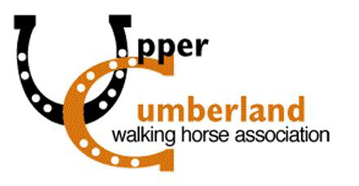
Class Sponsorship Form
43rd Annual Upper Cumberland Walking Horse Show
Saturday May 7, 2016 at Hyder-Burks in Cookeville, TN.

______ $200 GOLD SPONSOR (receive 6 tickets, recognition in show program, & name announced during class & show)

List preference (if any) of what class you would like to sponsor:____________________________

________ $100 SILVER SPONSOR (receive 4 tickets, recognition in show program, and name announced during class)

List preference (if any) of what class you would like to sponsor:____________________________

________ $50 BRONZE SPONSOR (receive 2 tickets, recognition in show program)

________ $25 FRIEND OF UCWHA SPONSOR (recognition in show program)

NAME (AS YOU WANT IT TO APPEAR IN SHOW PROGRAM): _________________________________________

ADDRESS: ____________________________________________________________________

CITY: ________________________________________________ STATE: __________________

PHONE NUMBER: ________________________

I agree to be a (circle one) GOLD or SILVER or BRONZE or FRIEND sponsor for the 43rd Annual Upper Cumberland Walking Horse Show.

___________________________________________
Contact Signature
Please send this form and payment to: UCWHA
P.O. Box 2645
(Forms due back by April. 23, 2016) Cookeville, TN 38502

For more information contact Jimmy Sherrell at 615-464-5047 or ibwalkin@dtccom.net

Net proceeds from this Horse Show help the Upper Cumberland Walking Horse Association provide scholarships for higher education, sponsorships for youth projects and donations to various other worthy programs that promote youth and the Tennessee Walking Horse.

